# Introduction

With the immergence of the modern world, the technology has reached at the highest peak with controlling the whole world. We can see everything as a digital and smart enough like T.V, smart phones, etc. As being cleverest creature in the world human being has made the technology under their control with the successful evolution of the internet.

Through this project we developed the web application for Furnishing Order System i.e. e-commerce website which can be used by any group of people and any age group who are directly connected to the internet. People can order any furnishing items presented there in the application and get the things with in a very short period of time. We have created different types of users into the system, they are admin and customer. Here the admin can perform all the CRUD operation of the application. Likewise, customer will be able to create their user id, select the items and add to the cart. The system generated the bill automatically after adding items into the cart and confirm by the admin.

# Problem Statement

Compared to traditional methods of buying and selling the items from the shop this application will be far better. As before the different furnishing store was managed manually in hand written form with a greater number of labors which is not sufficient for the emerging demands of the customer with the industry. Maintenance of the information is risky as compared to digital one. Everyone has their busy schedule and have their own problems. With this problem they are not going to waste their time sitting into the queue of the store. Thus, the system has been developed for mitigating all above-mentioned problem and digitalizing the system to more advanced with multiple features.

## Projects Plans

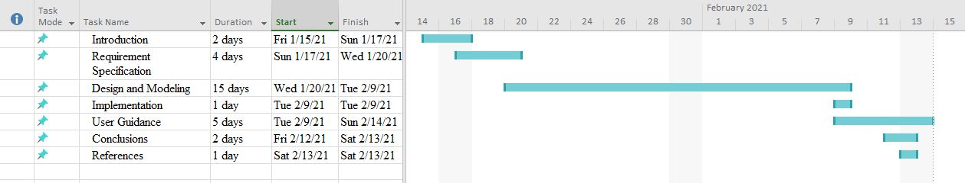

## Objective

* To make the furnishing items ordering process simplest and reliable.
* To make the traditional system into the digitalize one.
* To make easy for the customer in order to save their valuable time.

## Scope

As the world is running after the technology all the system are going to online day to day. With increase in ease of the customer our system can make the ordering system mote easy and the customer can order anything they want sitting at any corner of the world. Some additional feature that can be included in the coming days are: pre-booking of the items, delivery system of the items and so on.

## Aim

The aim of the project is to make digital system for the existing traditional furnishing order system, make the customer more comfortable and friendly to the system to order the items online.

# Requirement Specification

## Major function of the website

There are various functions in the web application but the major function includes what the users can performs into the system. Some of the major function of the website are discussed below:

1. Login/signup: Before proceeding any functionality into the website first the customer should login to the system. If the user does not have the login id they should first signup their account.
2. View items: All the items or product included in the website can be viewed by the users.
3. Add to cart: After viewing the items if the users wish to buy it then they can add to the cart.
4. Manage products and orders: The admin can only perform this functionality while the users can only view the product and add to the card and finally generate the bill. These all functionality is handling by the admin.

## Hardware Requirement

* Computer
* Processor: Greater than 1.8 GHz
* RAM: 8 GB
* Hard Disk: 256 GB or Greater

## Software Requirement

* Microsoft SQL server 2010
* Windows 8 or 10
* ASP.NET
* Visual Studio 2010 or above

## Mission Statement

The mission statement of the website is mentioned below:

* Enhance the relationship between the customers and shopkeepers digitally.
* Provide the detail information of the furnishing products in order to attract more customer.

# Audience Modelling

In audience modelling we have to refined the target users identified in the mission statement as below:

## Audience classification

Registered Users

Purchasers

Loyal Customer

Figure 1 : Audience Classification

## Audience Characterization

Let us consider an example in the furnishing order system website that we are going to propose. The audience class register users have two variants i.e., new users and existing users.

New users: New users are those who are new to the system and want to buy the furnishing products through online mode. This type of users may be the one who get attached by the popularity of the website.

Existing Users: This type of users is those who are very familiar to the e-commerce website. The age group between 20 to 30 are included in this type of users.

# Design & Modelling

## Database Schema (Data Dictionary)

### Signup Table

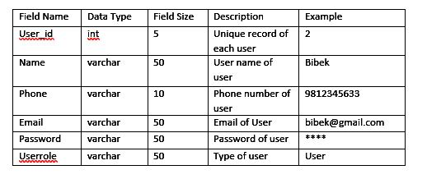

Figure 2:Signup table

## Contact Table

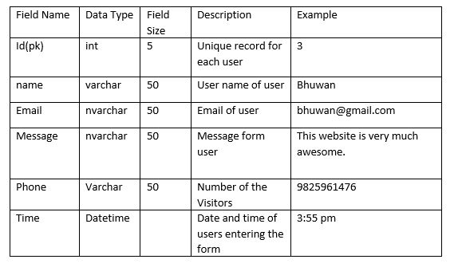

Figure 3:Contact Table

### Product Table

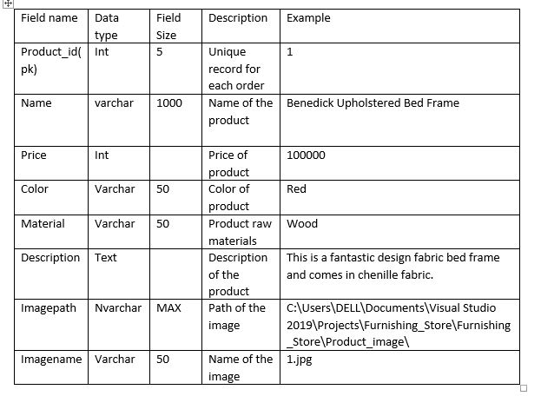

Figure 4:Product Table

### Add to cart table

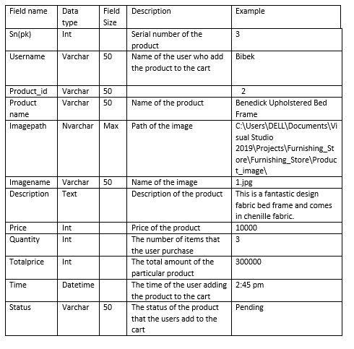

Figure 5:Add to cart

## Interface Design (Story Board)

### **Storyboarding**

Storyboarding is a graphical representation where a sequence of activity is shown or represented which can be accompanied by narration ether explicitly or implicitly (Newman & Landay, n.d.). It only shows limited details of the pages and the navigational links required to perform tasks.

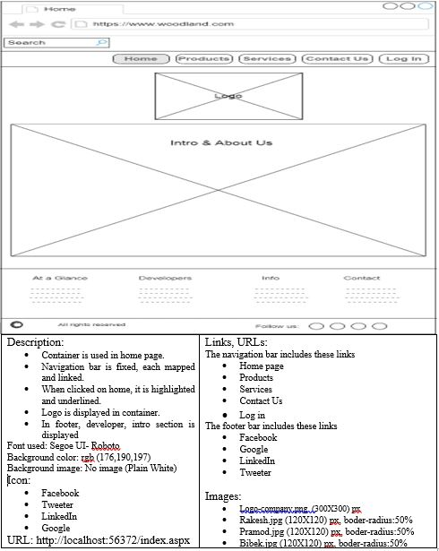Figure 6 : Story boarding of Home Page

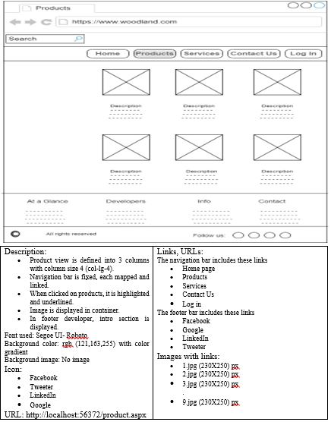

Figure 7 : Story boarding of Product Page

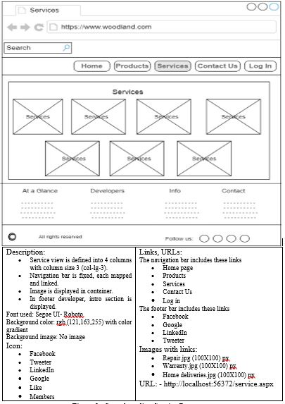

Figure 8 : Story boarding of Service Page

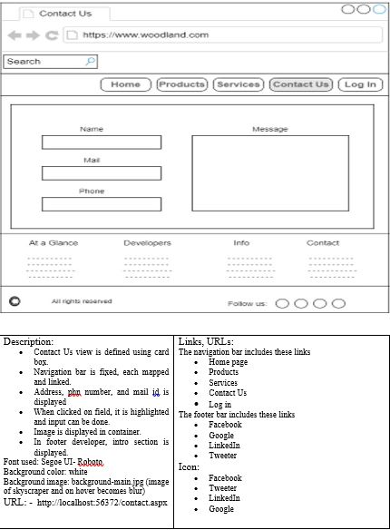

Figure 9 : Story boarding of Contact Us

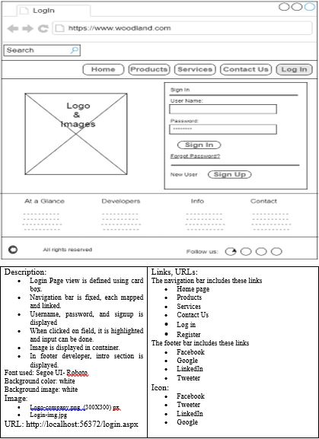

Figure 10 : Story boarding of Login Page

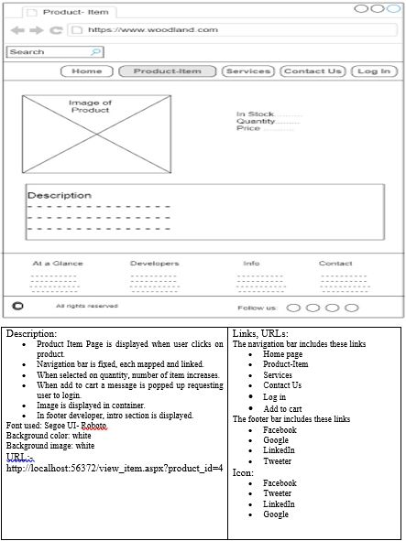

Figure 11 : Story boarding of Product Item

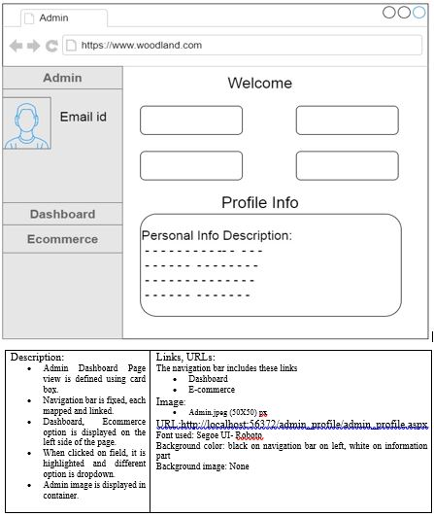

Figure 12 : Story boarding of Admin Page

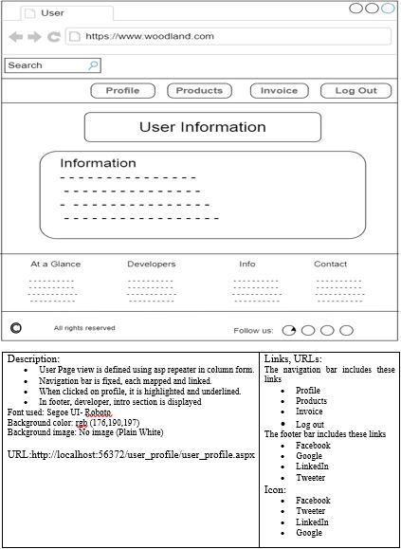

Figure 13 : Story boarding of User Page

## Website Architectures (Navigational Structure)

Navigation structure connects the users in the web application with the help of hyperlink in it. The main page of the furnishing management system consists of the following navigational structure.

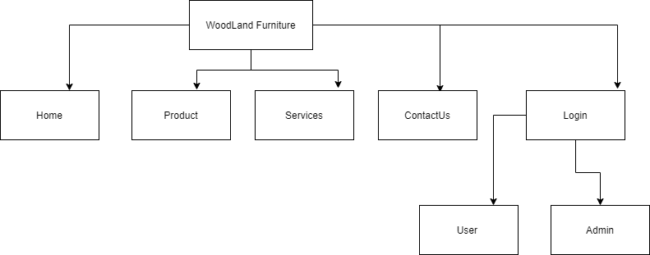

Figure 14:Navigational Structure of first page.

## User Navigation Structure

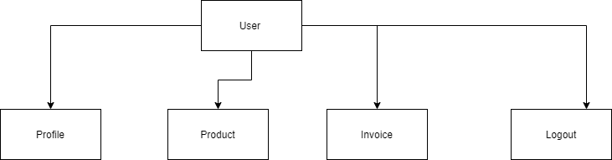

Figure 15:User Navigation

In the user navigation it consists of four Navbar i.e. profile, product, invoice, logout. After the successful login into the system by the user the above navigational structure appears.

## Admin navigational structure

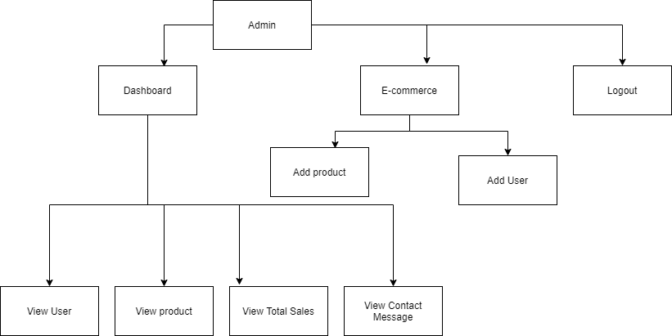

Figure 16:Admin Navigational Structure

The admin navigational structure consists of two different types of menu i.e. dashboard and e-commerce. Inside the dashboard the admin can view the user, view product, view total sales, view contact message. And in the e-commerce the admin can add the product and add the user.

# Implementation (Code Snippet)

## Create

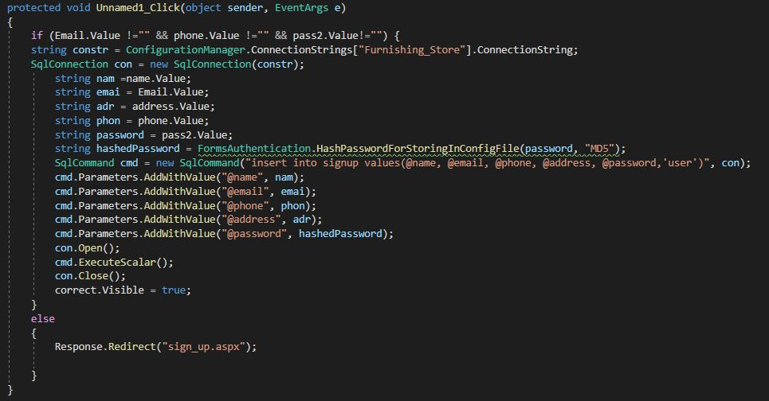

Figure 17: Create code snippet

The above picture is a code snippet of the create operation on the signup form. Here at first, we connect to Microsoft SQL server management studio by declaring the variable as “constr” and applying the “SQLConnection” command to create a connection. Then value from the signup form that needs to insert into the database is declared as a string variable. Password that gets from the users is Hash using “Forms Authentication” and we used the “SQLCommand” to insert data. Here using the parameter, we passed the value using “@” in the database. Database connection is open and execute code as “ExecuteScalar()” then closed and make the success message visible at the end.

## Read

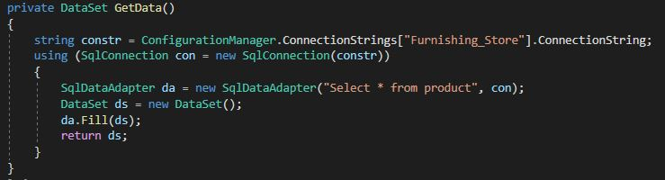

Figure 18: Read query

Fig 2 shows the SQL query and database connection. We have created the DataSet class where we connect the webform to a database and used the SQL command. “SqlAdapter” is used to read SQL queries. Then “DataSet” is created and fill the data get from the SQL.

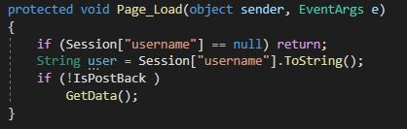

Figure 19: Reading data

At the “Page_Load” class we have passed the dataset class value and function as “GetData()”. This helps to read and show the data that get from the database.

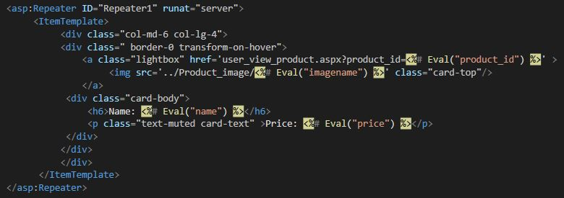

Figure 20: Reading value in aspx

Figure 3 shows the reading value from the database in “Repeater1”. Using the “ItemTemplate” we make the design and placed the value to read from the database as <%Eval(“filename”) %>. By this we get the clear value from the database and Repeater helps to create all the values present in the database.

## Update

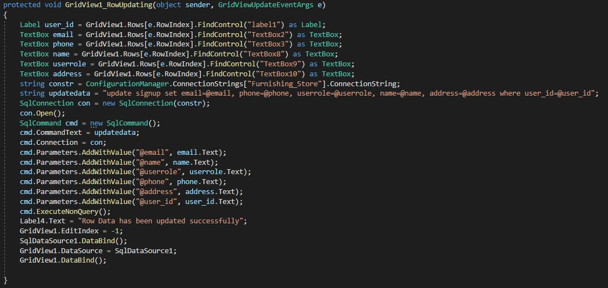

Figure *21*: Update

Figure 4 shows the update process used for the development of our website. Here at first, we create the textbox in the “EditTemplate” inside “Gridview”. While we click on gridview edit button it turns the label into a textbox where we input data. Here is the code, it declares the variable for each textbox and connects the database. Using the update query of SQL, we used the parameter to turn the value as SQL parameter to place in a database. Then execute the command using the “cmd.ExecuteNonQuery()” command. After this, we flash the success message at “Label4.Text” and used EditIndex as -1 then bind the data into the database on SqlDataSource1.

## Delete

## 

Figure 20*2*: Delete

Here in figure 5, we have used the “Repeater_ItemCommand” on Repeater1. Here in the “aspx” file, we have passed the query of the selected product id on the repeater. Using the link button, we place the command argument as “Delete”. The selected command is passed as a string and connects the database. Then we run the database query to delete the selected id of the product then execute the code and at last, we bind the data.

## Login

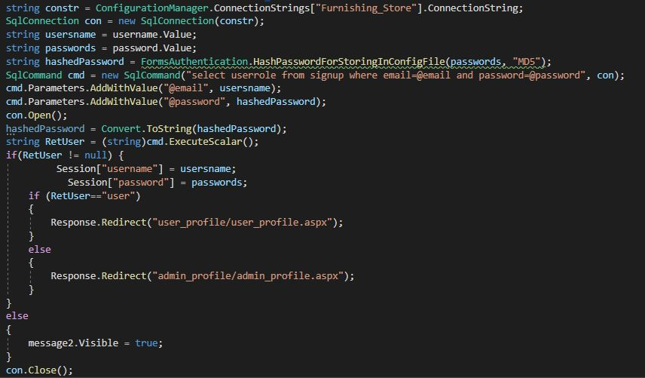

Figure 21: Login Code snippet

Fig 6 is the screenshot of the login process. Here at first, we have connected to the database and SQL server. At first, we get the value from the login page and convert it to the string variable. Then the password that put-on login should be hash. So, for using the “FormAuthentication” we convert the password to hash form and make variables for it. From the SQL command, we select the username and then search on the database to match the “userrole”. Executing the command, we compare it to “userrole” and used “if else” command. If the userrole is equal to user it redirects to the “user_profile/user_profile.aspx” page and else redirect to “admin_profile/admin_profile.aspx” page. For every login, before redirecting we passed the session id that can be viewed on the next page. After this, it will make the message visible and close the connection of the database.

# User Guidance

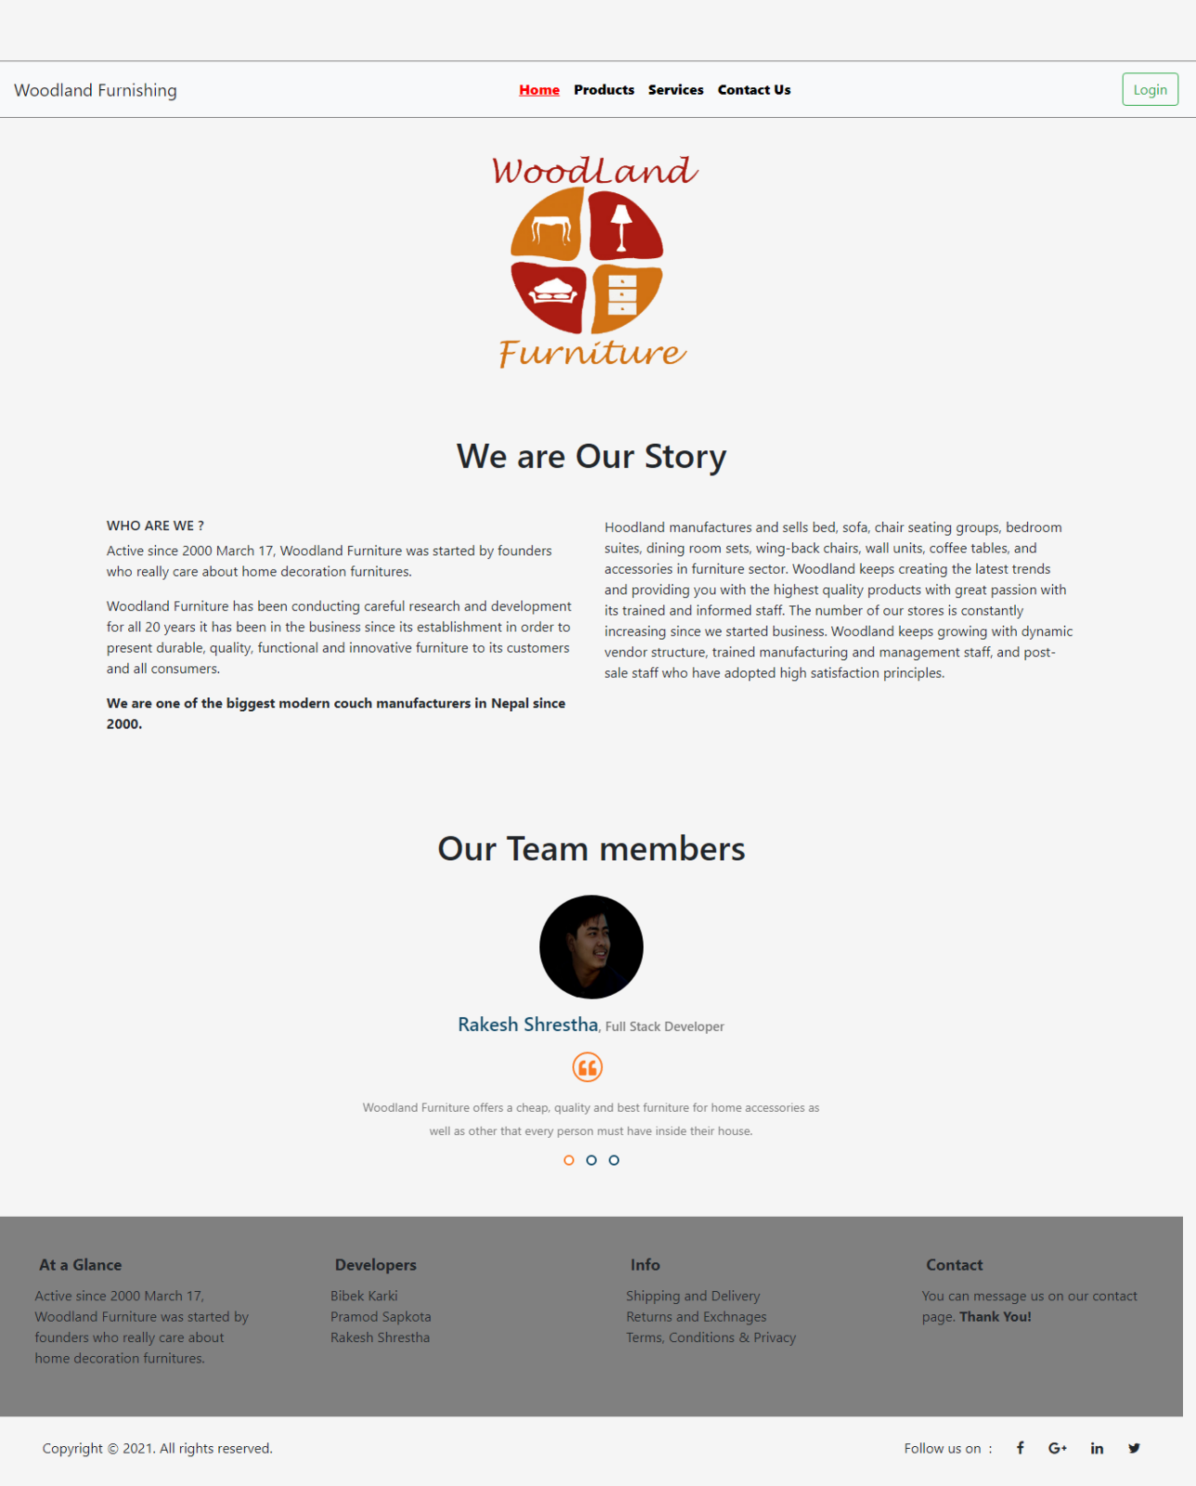

Figure 24 : Home Page of WoodLand Furniture

Above shown figure is a screenshot of home page of WoodLand Furniture. Here in the home page we can see logo of the company, description of the company, team members and social media handles. Through the home page we can navigate to different pages like products page, login page, contact us page and so on.

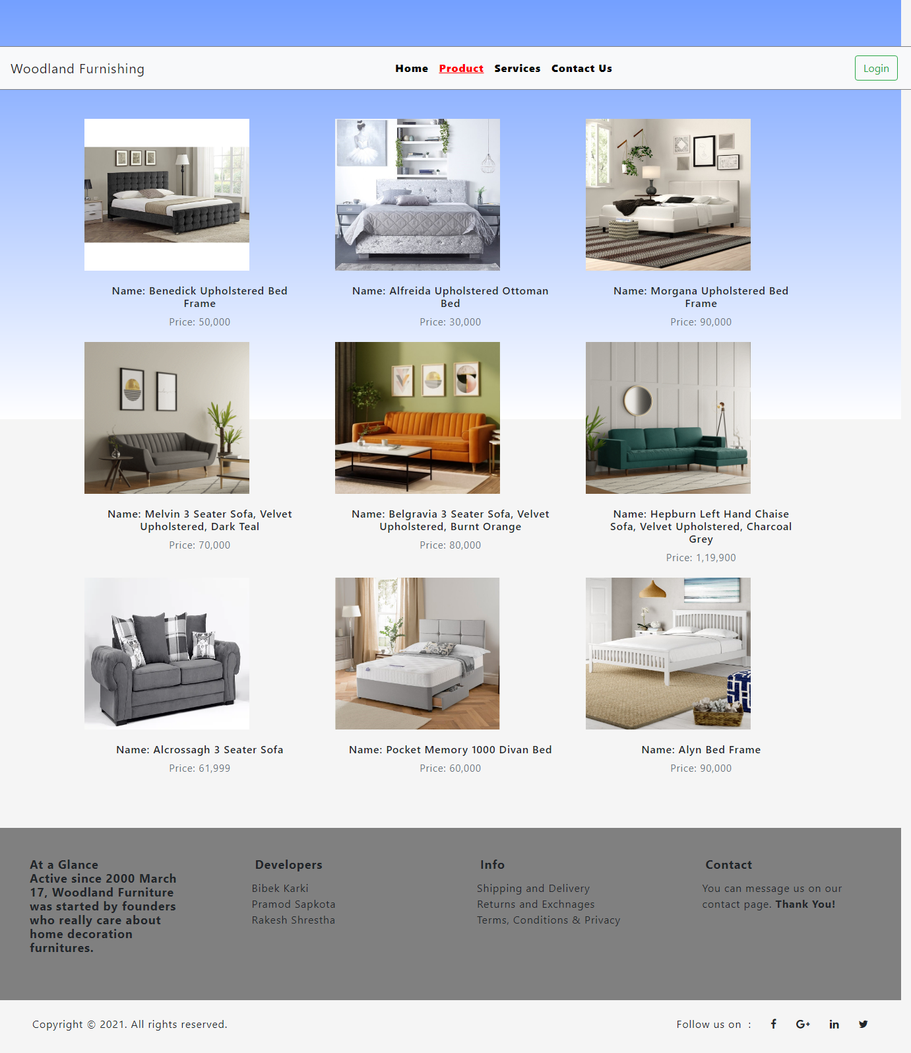

Figure 25 : Products page

Above figure shows the list of products that are available and are displayed with the images and prices.

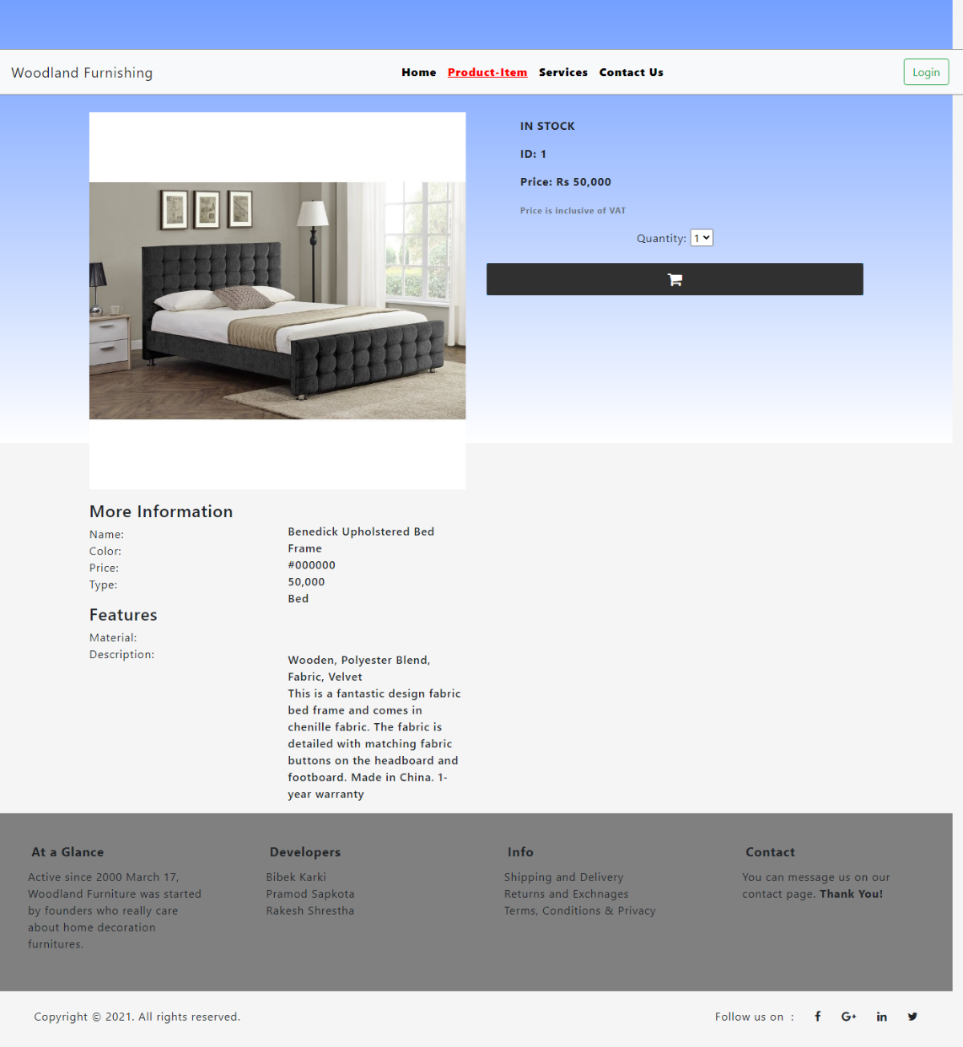

Figure 22*6*:Product Detail

The above page shows the product details after the user clicks into the particular product. Here they can see the product features with its detail information.

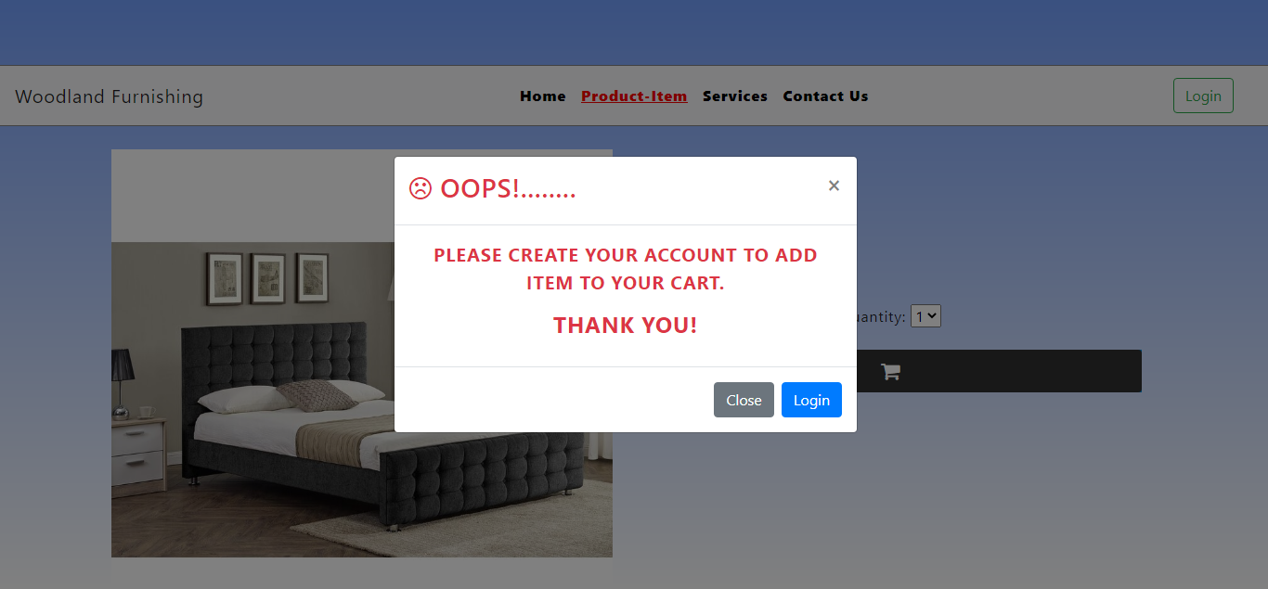

Figure 23:Add to cart pop up message.

If the user adds the product to the cart without login into the system, then the above pop up message is seen in the screen. If the users want to buy the products, then they should go to the login and create the account and sign into the system.

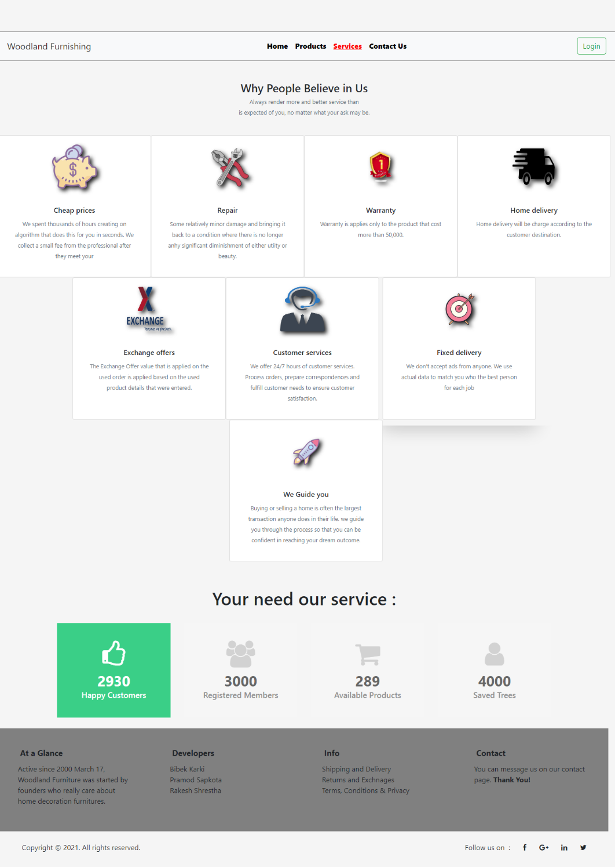

Figure 24 : Services

Above screenshot is the services page that shows the services that our company provides to the customer.

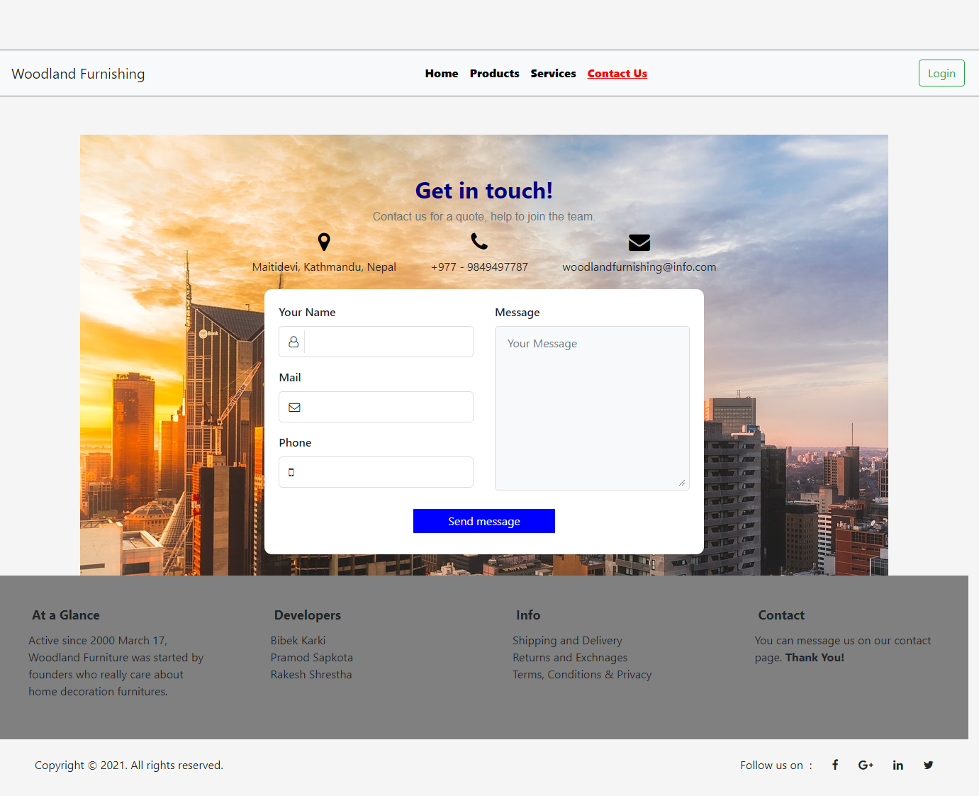

Figure 25:Contact

The page shown at above is of contact page. Here the user can contact to the company. By clicking on send message button and filling the above input field they can message or give feedback.

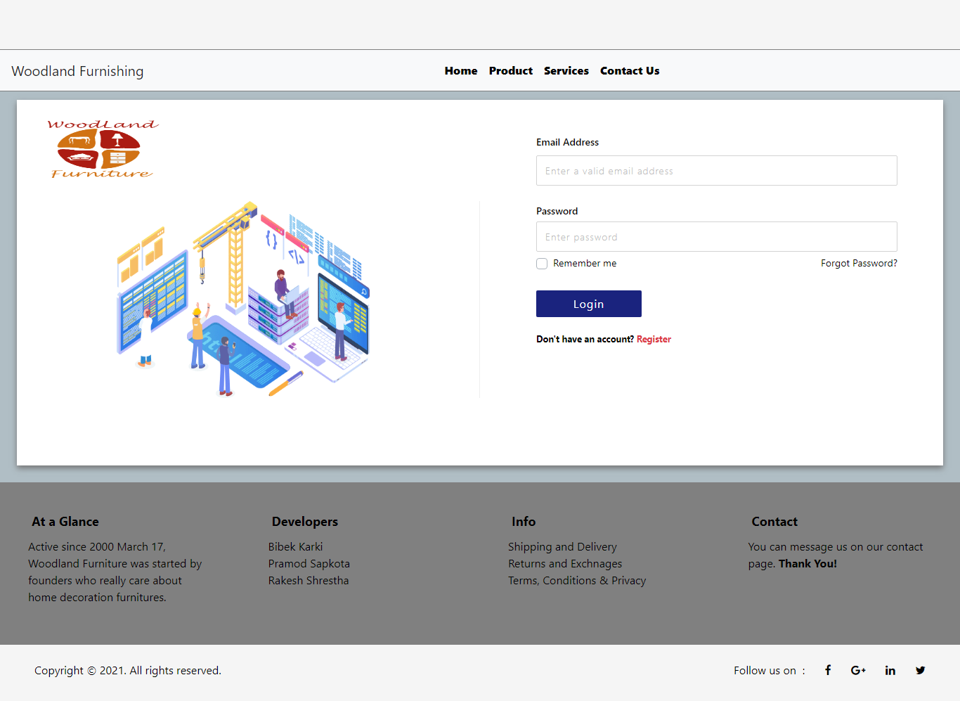

Figure 29 : Login Page

Above figure shows the login page of the Woodland Furniture. This page is displayed when the user clicks the login button. Through this page we can go to signup page as well. Users as well as admin can login through this page.

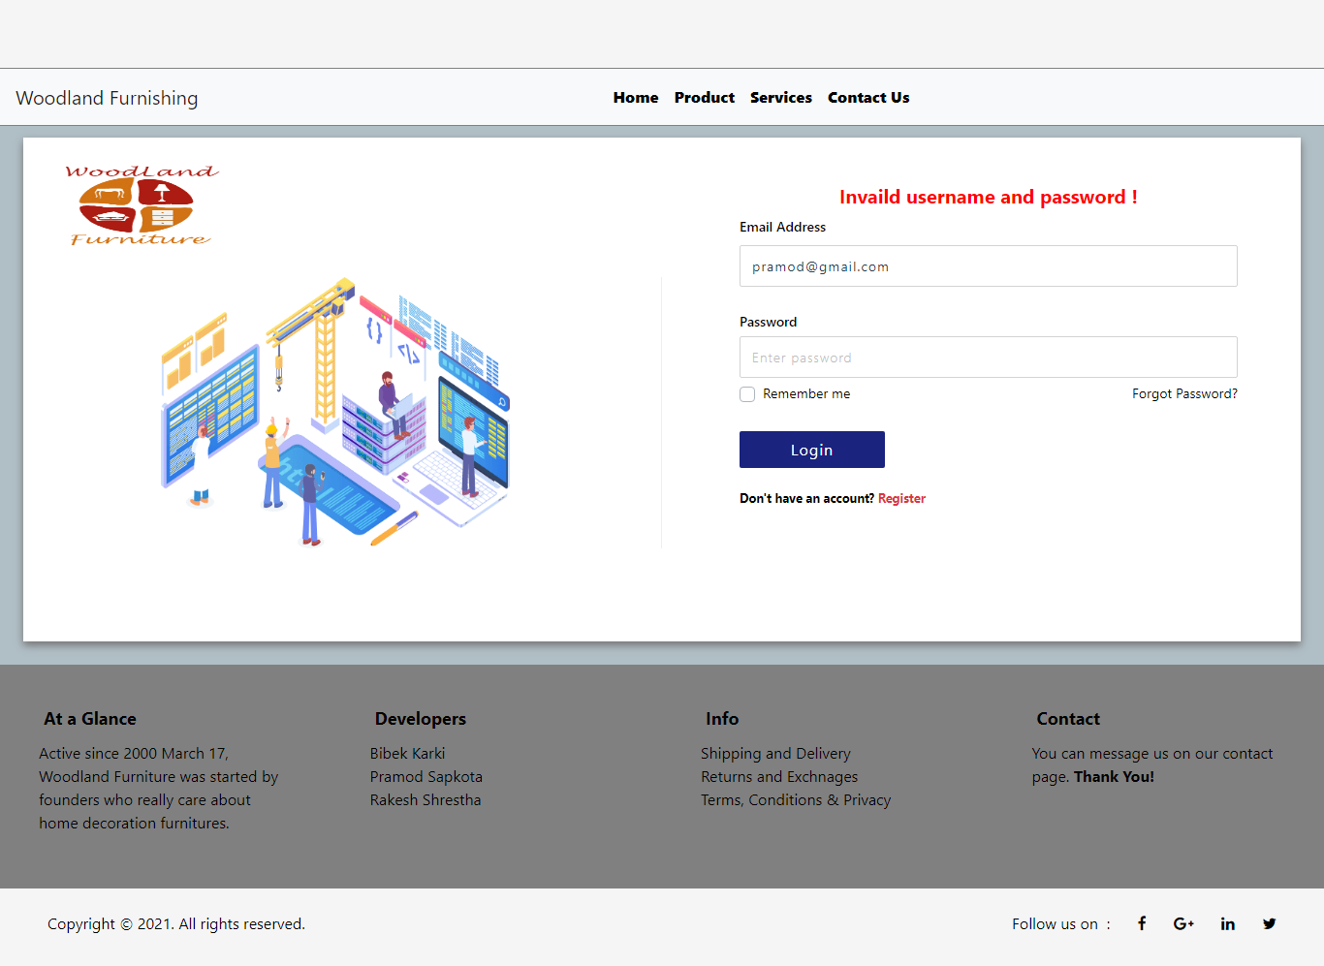

Figure 30: Login error

When the user input the wrong password or username it flash the error at top as “Invalid username and password” in red color as shown in above figure.

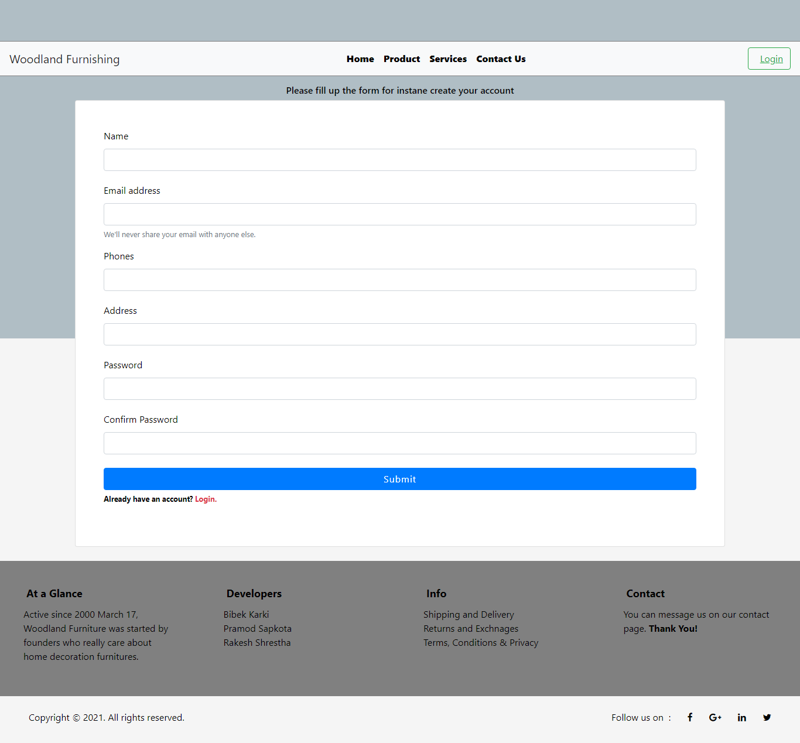

Figure 31 : Sign up Page

Above shown screenshot is the signup page where new user can register themselves. Details like name, phone number, email address, password and address are required to sign up for new users.

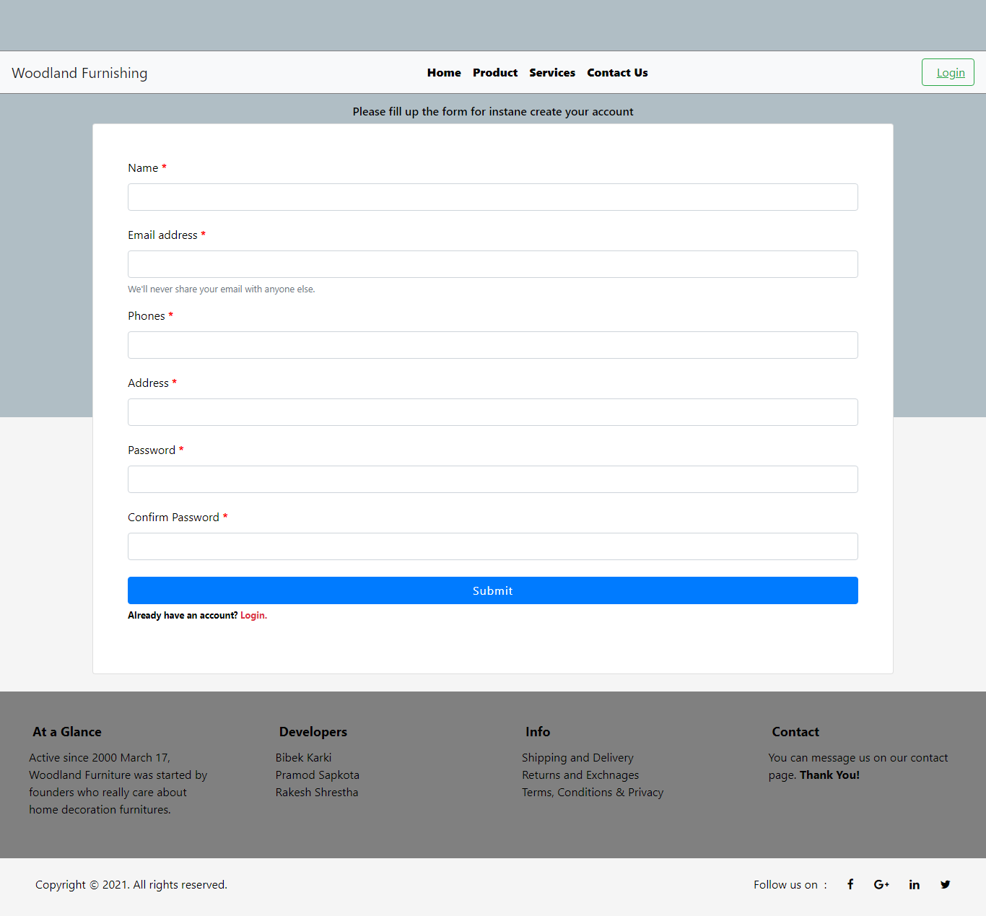

Figure 32 : Sign up Page

When the user did not put any information while signup then it flashes the validation required message in red color when submit is clicked. Similar validation process is done in contact and other pages also.

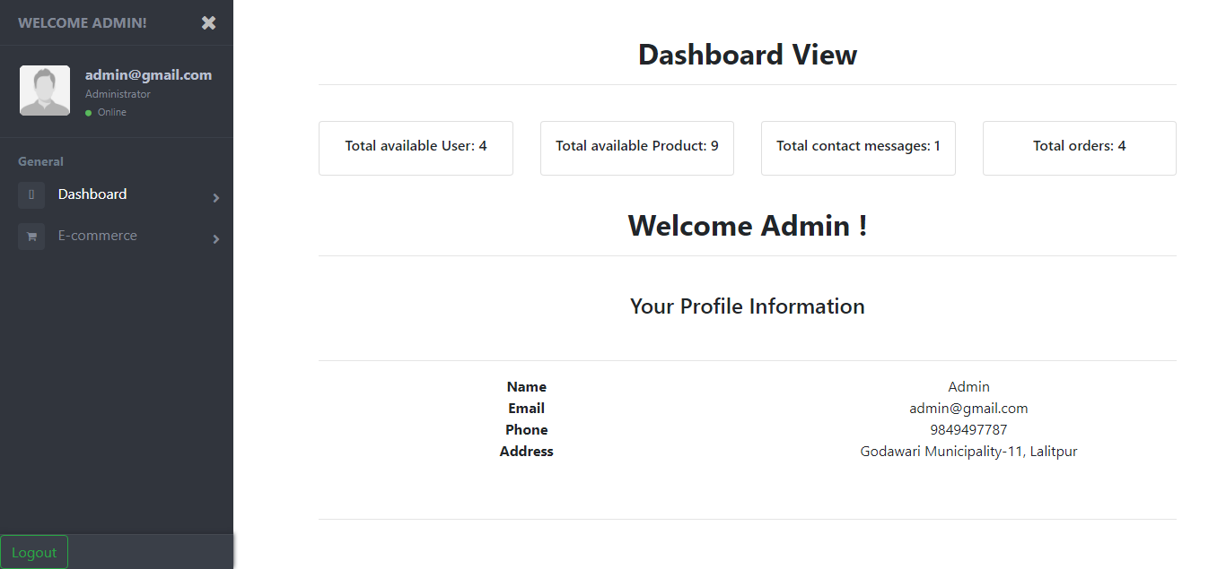

Figure 26:Admin page after login by admin.

After the successful login by the admin then the above-mentioned screen appears where the admin can see their profile information. Also, the total available user, total register admin, total available product and total register user is displayed. In the left side the dashboard and e-commerce menu appear.

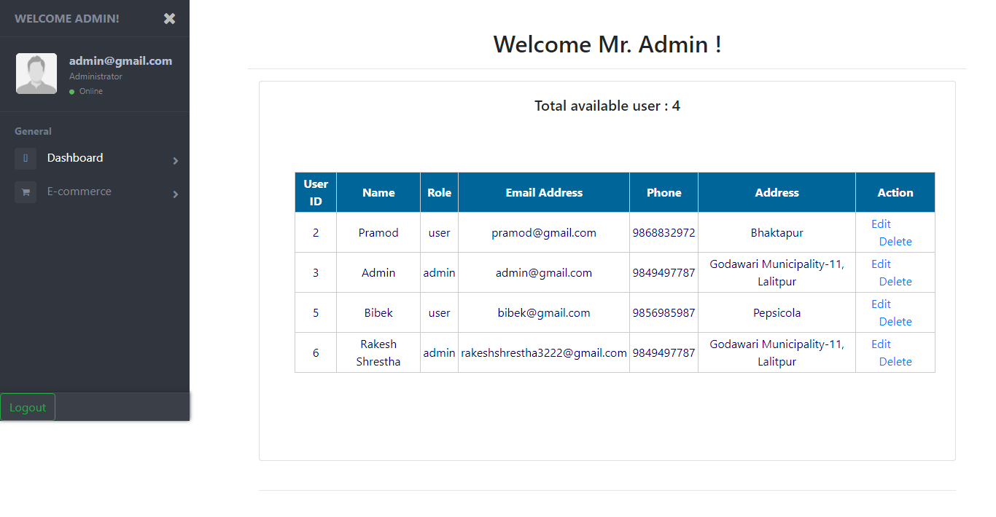

Figure 31: View users.

When the admin clicks the dashboard then open the view user’s menu then the above displays appears where the admin can view the available users that are registered into the system. Also, the admin can edit and delete the users as per the requirement.

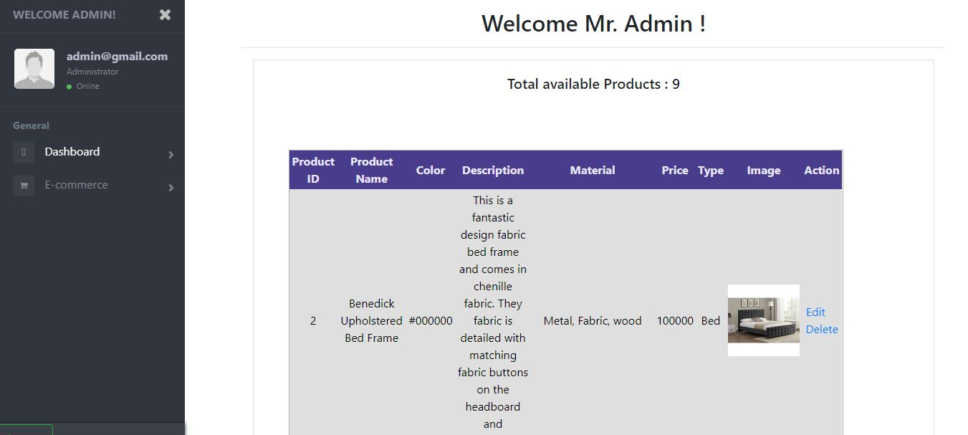

Figure 27:View Product.

The above screenshots show the list of available products where the admin can edit and delete the products.

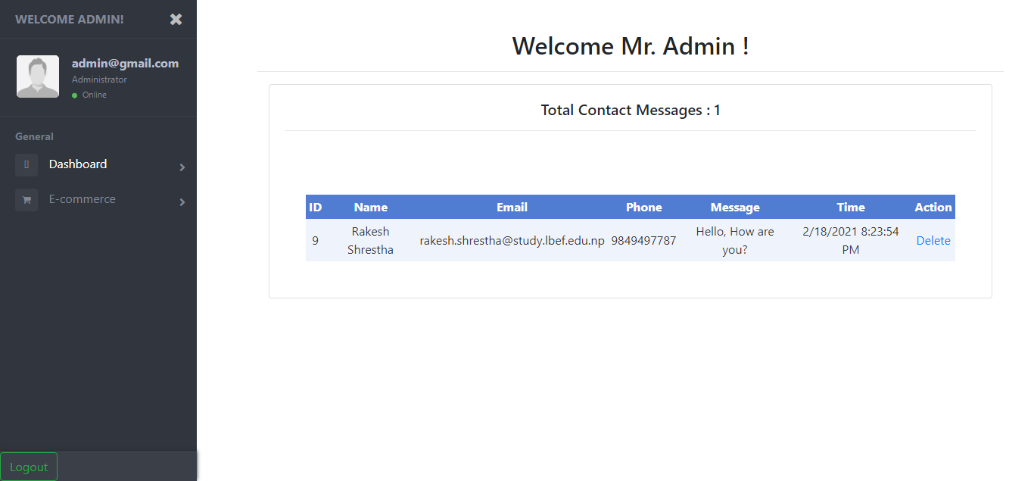

Figure 28:Contact form message.

This shows the messages that the users submit by filling the contact form. The admin can delete the message response.

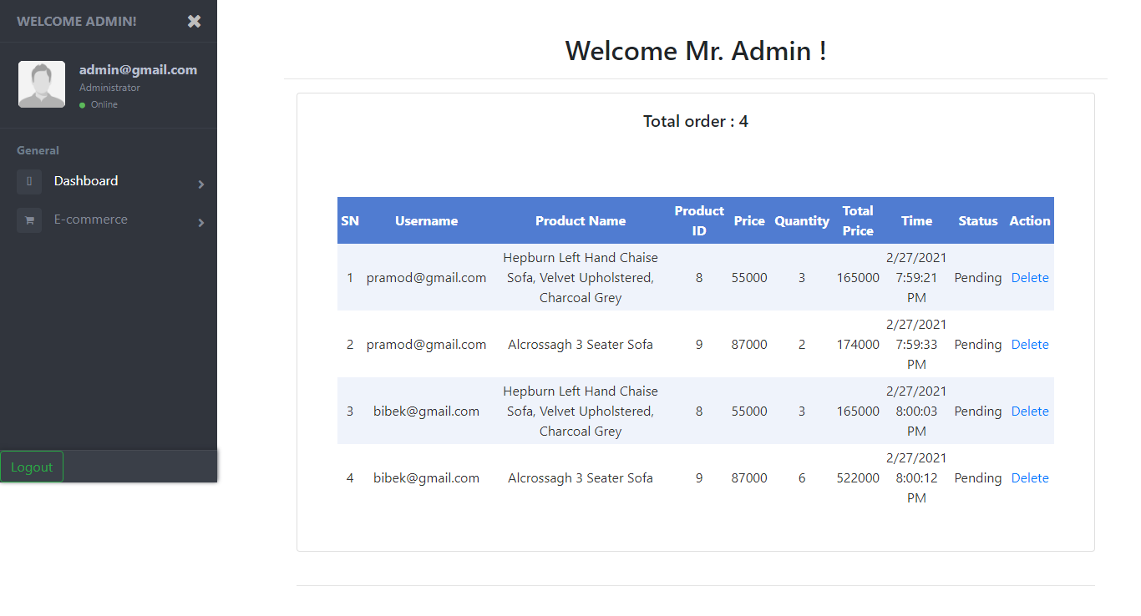

Figure 29*4*: View total sales order.

The above displays show the total sales order of the product that the users add to the cart. The admin can delete the order.

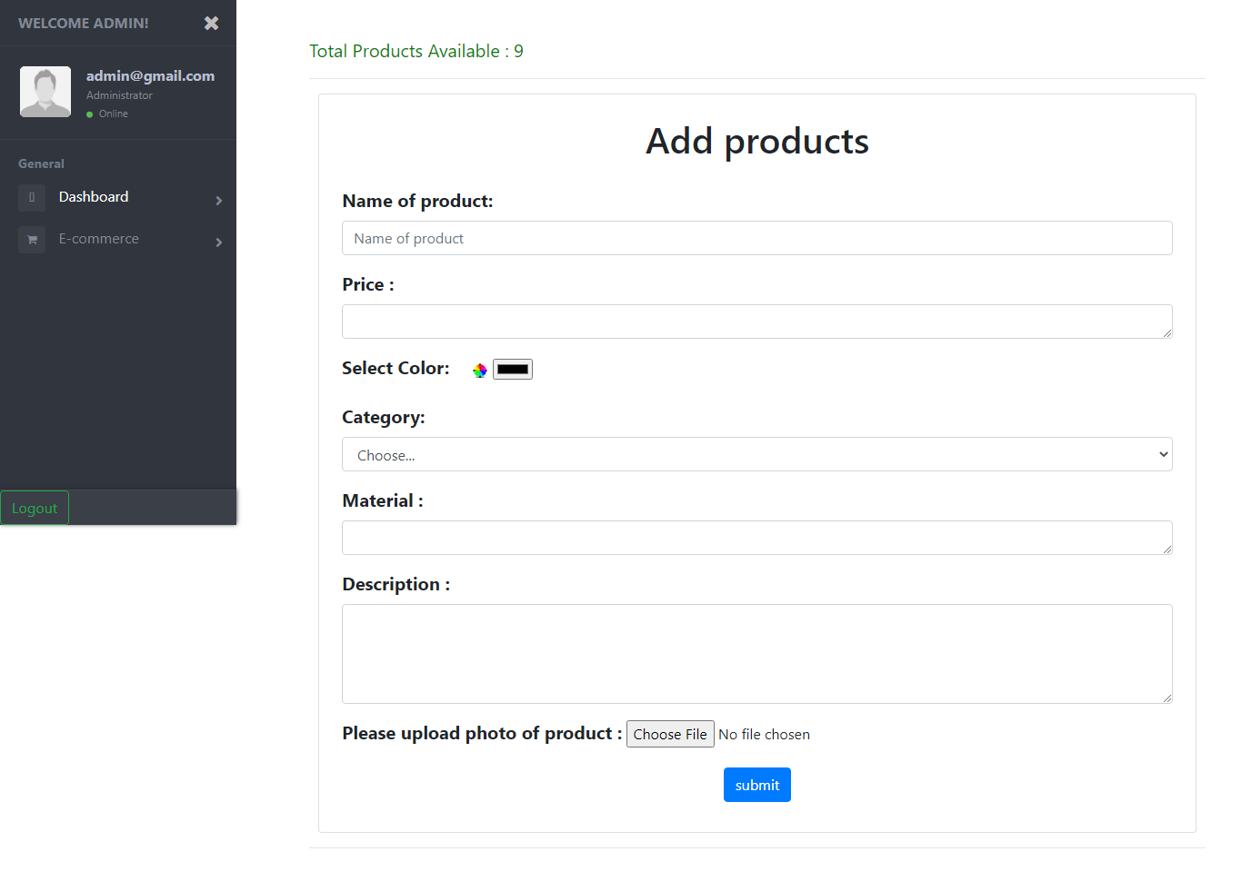

Figure *35* Add product.

Inside the e-commerce menu the admin can add the product and user. Here in the above screenshot, it shows that the admin can add the product with mentioning all the product details.

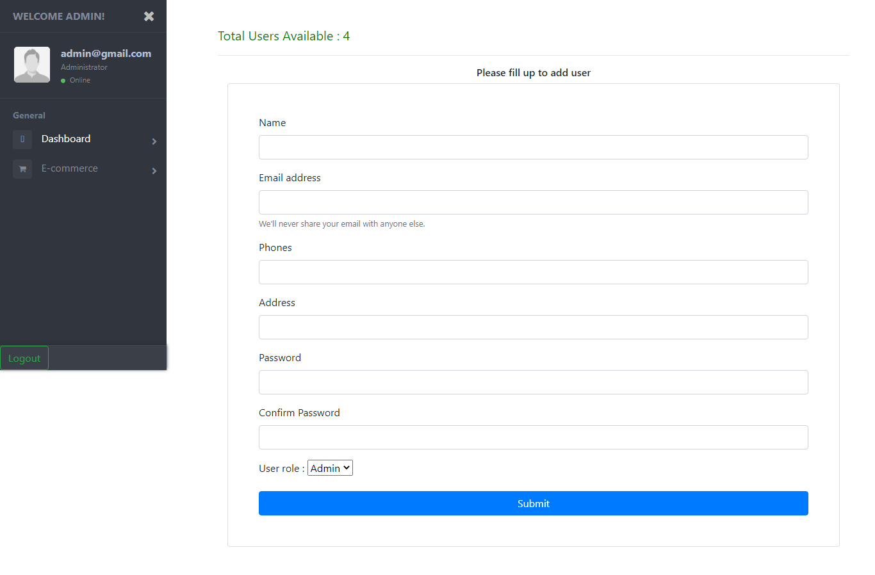

Figure 30*6*:Add User.

In the above screenshot inside the e-commerce menu it shows that the admin can add the users directly from the admin page by mentioning the user role.

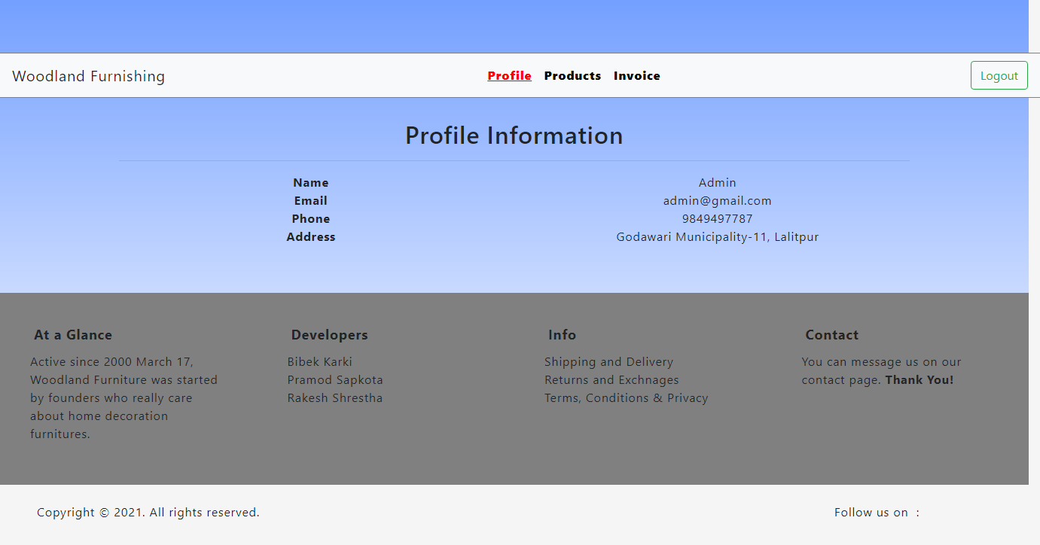

Figure 31*7*:User profile.

After the successful login by the users this page appears in the screen. Here the user can view their information, buy the products and view the invoice.

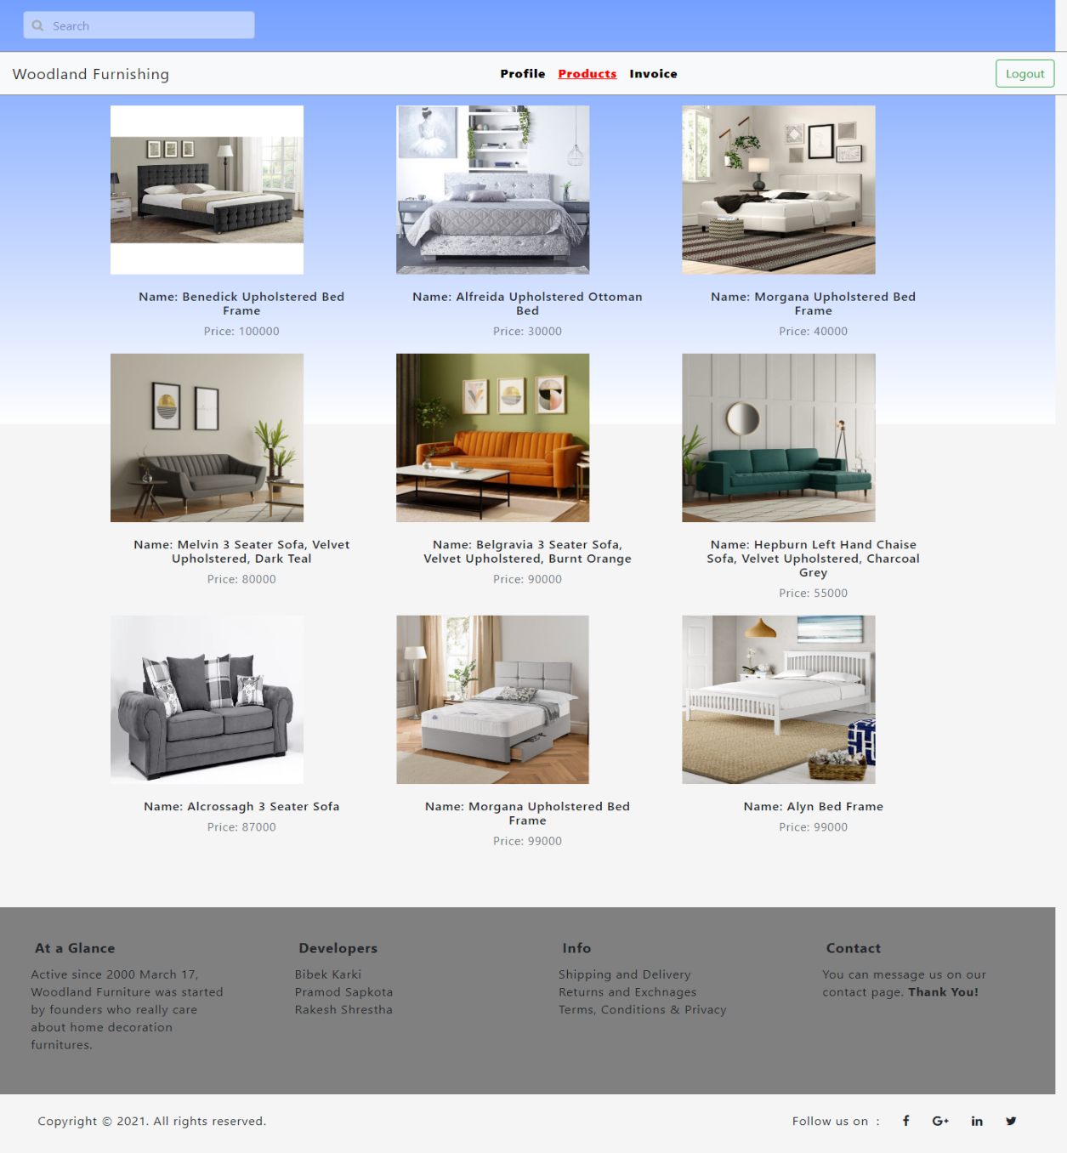

Figure 32*8*:Products

When the users click in the products button, it shows the list of product as shown above.

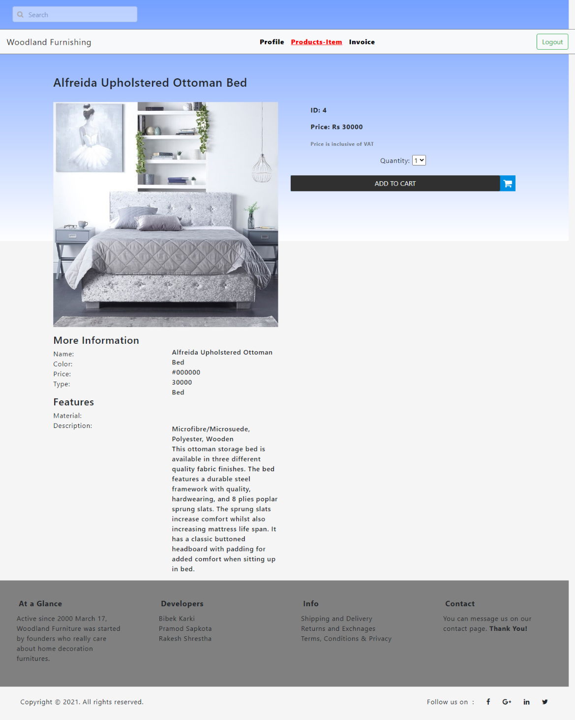

Figure 33*9*:Add to cart

After clicking the specific product, the above page appears. By mentioning the number of quantity the users can add the product to the cart.

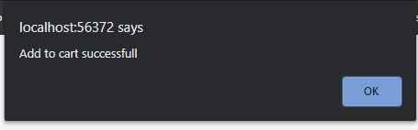

Figure 40: Alert message.

By adding the product into the cart the above message appears which shows the successful of the product adding to the cart after clicking the add to cart button.

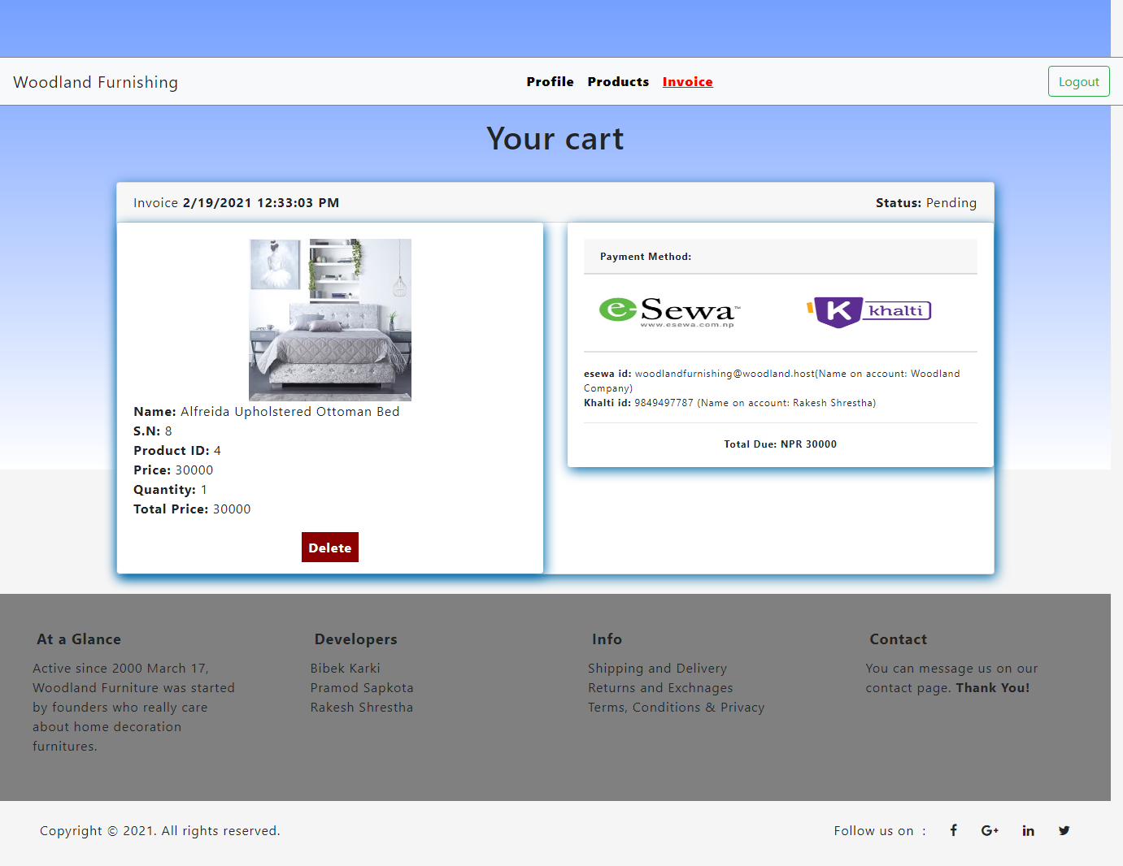

Figure 34:Invoice Generated.

The users can view the invoice after successfully adding the items to the cart and can view which product they have added to the cart. For the payment we have provided the different payment services which will be integrated in the coming future.

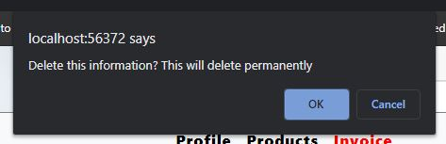

Figure 35:Deleting invoice

The user can delete the invoice and the above screen shows the confirmation before deleting the invoice.

# Conclusion

A system for furnishing order system is developed by using ASP.NET by performing the audience modeling and addressing the different types of people. In this system, the registered user can view the items and buy it. In our system there are different type of user i.e. admin and customer. Here the customer can create the id and login into the system and perform the various task like add to cart and view the invoice. Furthermore, in the coming future we are going to add delivery services and payment methods through e-sewa and Khalti.